CL01FW upgrade SOP
Tool: Micro USB cable & PC (Windows)
SW: Driver / install SW(Stmlps) / CL01 new FW
- Copy driver and SW into PC (3 items)
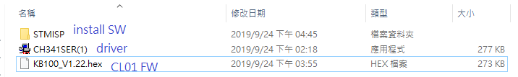
- Connect CL01 to PC via micro USB cable
- Open STMISP file to find Stmlsp and then click it
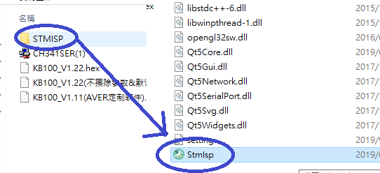
- Burn the FW code into CL01 from PC
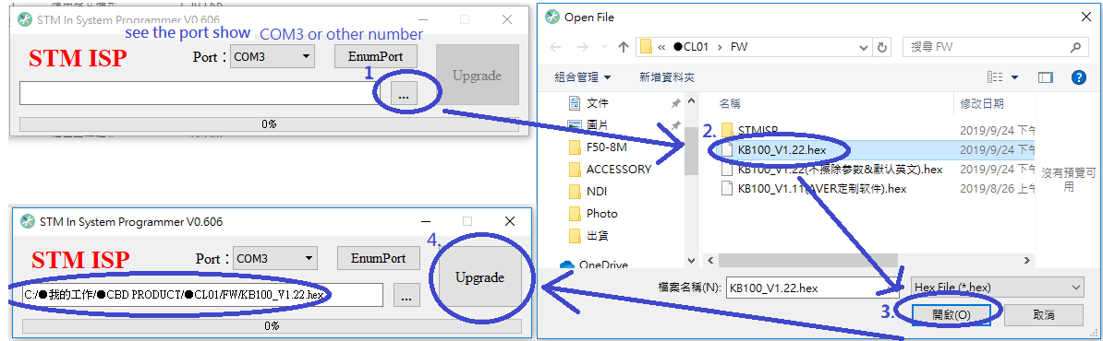
- Wait the run bar to 100% and “unplug” the CL01 to check the FW version on CL01
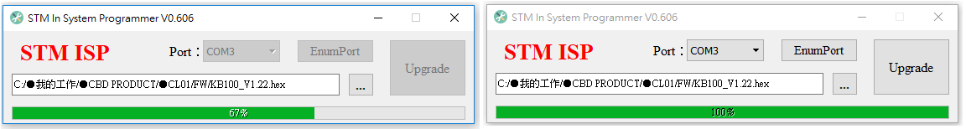
Long Press CL01 “MENU” button and use joystick to find the FW version


